Part 1)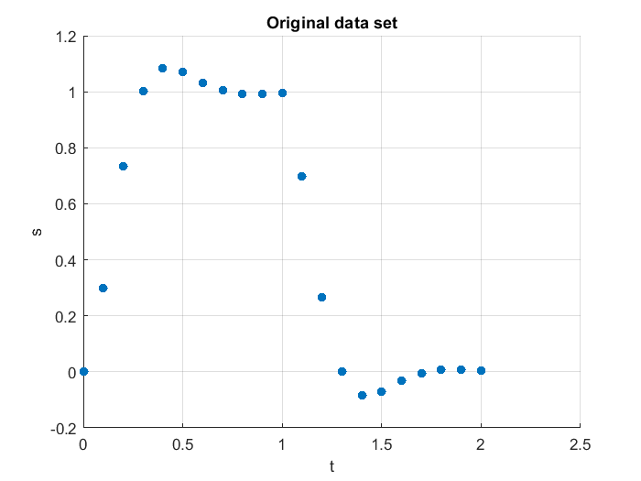

Part 2)

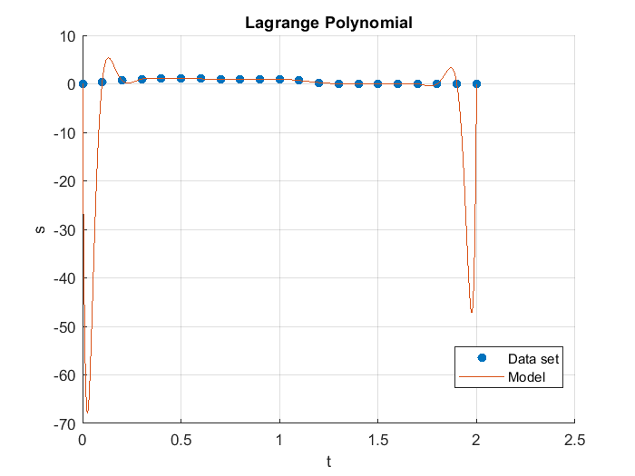

Part 3)

P(x) = -0.6749930x^2 + 0.8683653 x + 0.5304204

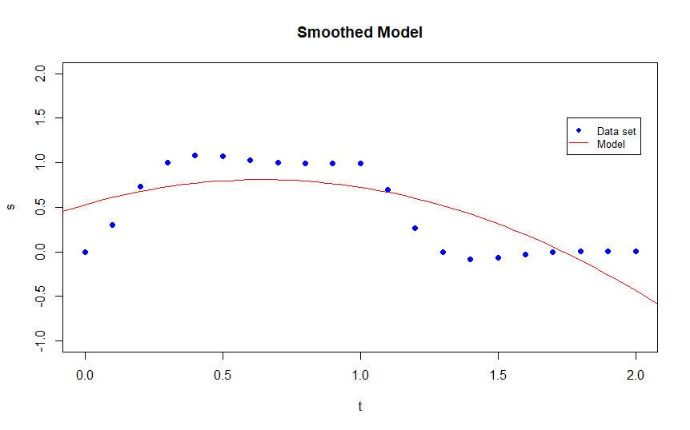

Part 4)

For the Lagrange model, at t=1.45 the prediction is P(1.45) = -0.07455

For the smoothed model, at t=1.45 the prediction is P(1.45) = 0.3704